DATA TABLES: Organizing Information (Day 7)
  - INTRODUCTION:
    - Experiments produce data that support or reject hypotheses.
      - The word data is just the scientific term for information.
      - Scientists usually collect data in the form of numbers because most of their activities require measurements.
    - Scientists not only have to use numbers. They must also use units to describe the numbers.
      - All numbers must be identified by the correct unit.
    - Recording data and measurements means writing down many numbers. But numbers must be organized to be meaningful.
  - DATA TABLES:
    - Data is organized in Data Tables.
      - A data table is a chart that organizes numbers in rows and columns.
      - Scientists use data tables to communicate their finding simply and clearly.
      - Table 1: Motor Vehicle Pollutant Emission per Vehicle-Mile Travel 1970-1981 (grams/mile)
Pollutant | 1970 | 1974 | 1975 | 1976 | 1977 | 1978 | 1979 | 1980 | 1981
Carbon  Monoxide | 86.9 | 79.0 | 77.0 | 74.3 | 71.4 | 68.3 | 65.2 | 60.6 | 55.5
Hydro-  carbons | 12.1 | 9.9 | 9.4 | 8.9 | 8.4 | 7.9 | 7.3 | 6.6 | 5.8
Oxides of Nitrogen | 4.7 | 4.7 | 4.6 | 4.4 | 4.1 | 3.9 | 3.8 | 3.6 | 3.4
NOTICE:

      - Tables are numbered in the order in which they appear.
      - The TITLE tells what information is in the table.
      - The table often has a box rule drawn around it. The table is usually divided into rows and columns.
      - The rows and columns have HEADINGS, and sometimes subheadings, to explain their information.
      - The units used in the table are shown in either the headings or the title.
  - CONSTRUCTING YOUR OWN TABLES:
    - The Five main parts of a Data Table: Number, Columns, Title, Rows, and Box.
    - Tables are used by everyone every day.
  - QUESTIONS:

    - Why do scientists collect data in numerical form?
    - What information is in Table 1 above?
    - Which pollutant shows the least change in Table 1?
    - What units are used to describe the numbers in this table 1?
    - What years are missing from the table 1?
    - When did the greatest reduction in carbon monoxide emission take place in table 1.
Table-2-: World Series Players Bonuses

Year | Winning Team | Bonus $ | Losing Team | Bonus $
1961 | Yankees | 7,389 | Reds | 5,356
1962 | Yankees | 9,882 | Giants | 7,291
1963 | Dodgers | 12,794 | Yankees | 7,874
1964 | Cardinals | 8,622 | Yankees | 5,309
1965 | Dodgers | 10,297 | Twins | 6,634
1966 | Orioles | 11,683 | Dodgers | 8,189
1967 | Cardinals | 8,314 | Red Sox | 5,115
1968 | Tigers | 10,936 | Cardinals | 7,078
1969 | Mets | 18,338 | Orioles | 14,904
1970 | Orioles | 18,216 | Reds | 13,688
1971 | Pirates | 18,465 | Orioles | 13,905
1972 | A’s | 20,705 | Reds | 15,080
1973 | A’s | 24,617 | Mets | 14,950
1974 | A’s | 22,219 | Dodgers | 15,704
1975 | Reds | 19,060 | Red Sox | 13,326
1976 | Reds | 26,366 | Yankees | 19,935
1977 | Yankees | 27,758 | Dodgers | 20,899
1978 | Yankees | 31,236 | Dodgers | 25,483
1979 | Pirates | 28,236 | Orioles | 22,113
1980 | Phillies | 34,693 | Royals | 32,211
[Use Table 2 above to answer the following questions]

    - In what year did the Orioles make the most money?
    - How many times were the Yankees in the playoffs?
    - What is noticeable about players’ bonuses starting in 1969? Table-3-: The Population of the United States
Year | 1920 | 1930 | 1940 | 1950 | 1960 | 1970 | 1980
Population In  Millions | 106 | 123 | 132 | 151 | 179 | 203 | 226

Use Table 3 to answer the following questions.

    - Which DECADE, or ten-year period, had the greatest population growth?
    - People tend to have fewer children during economic depressions. By looking at the table 3, in which decade did a depression probably occur?
    - Construct a table with the data in the next paragraph. Look back through the chapter if you need help, but first see how many of the five parts of a table you can remember by yourself.
{In 1972, the United States imported 811 million barrels of oil. In 1973, 1,184 million barrels came in. In 1974, the number was 1,296 million. There were 1,498 million barrels in 1975, 1,983 million in 1976, 2,414 million in 1977, 2,320
million in 1978, and 2,332 million barrels in 1979.}

    - Look at your table above to decide which year had the greatest single increase.
    - Judging from the number of barrels imported from year to year, when did conservation practices begin to have an effect?

[Refer to table 3 for questions #15-19]
    - What was the period of the statement in Table 3?

    - How many checks were written in Table 3?

    - How much money was deposited in Table 3?

    - What is the beginning and ending balance in Table 3?

    - Was there any interest paid? How much?

Table 3: Checking Account Statement
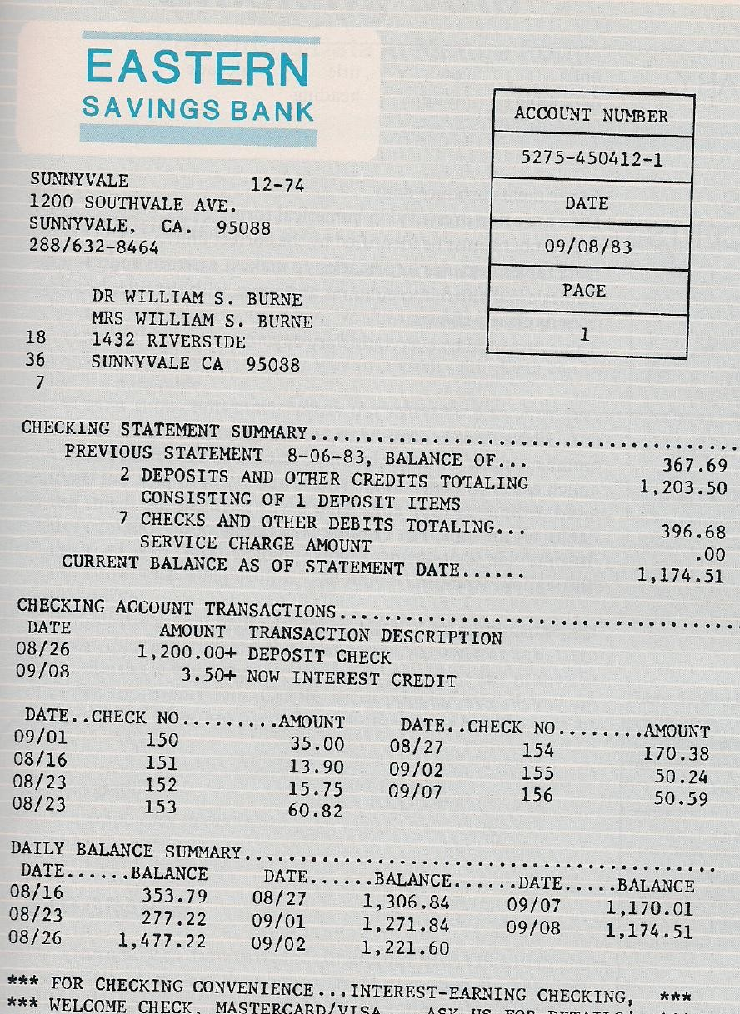

  - ACTIVITY: Measuring Bounces (Materials: Set of balls and a meter stick)
    - Drop the balls onto the floor. Notice that each ball bounces to a different height. If you were asked to choose the ball that would bounce the highest, which would you choose: What is your hypothesis about which ball would bounce the highest?

    - Work in pairs. One person hold the meter stick and drop the ball. The other person should read how high the ball bounces and catch it.
    - Before you begin, you must decide on the procedure of the experiment. To keep this experiment controlled, all balls must be dropped from the same height. To allow for errors, each ball should be dropped several times.
    - All of your data will go in a table. Draw a table. Remember the five important parts of a table. The table should be numbered. The title tells what the information in the table is all about. The data is boxed in rows and columns.
    - Remember to have enough rows and columns to record all the trails of each ball. Include space to record the height from which they are dropped. The columns and rows need heading to identify them.
    - Don’t forget the units you will use to measure the heights of the bounces. Finally, include a column to show the average height each ball bounced.
    - Which unit did you use to measure height---meters, centimeters, or millimeters?
    - Do the experiment. Enter your data in the table.
    - Find the average height bounced for each ball and enter it in the table. If you don’t remember how to average, do it this way. Add up all the bounce heights for one ball. Divide that number by the number of trials.
    - Run your eye down the column that shows the average height each ball bounced. Which ball bounced highest? Prove it with your data.

